2024 Recreational Crab Creel

Protocols and Equipment

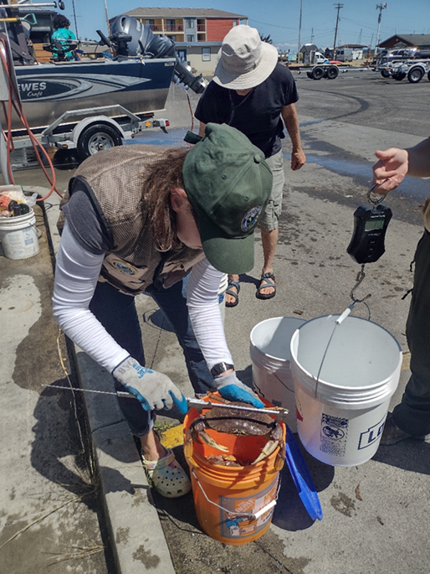
Photo By WDFW

Crab Creel Sampling Protocol:

- Before leaving the office: Check that all your gear is organized and in possession, you have signed out an assigned/available vehicle, and your scales are calibrated using the calibration weights.

- Be at your designated sampling site in a timely manner. Check the schedule to see if Amy Pumputis or Blair Winnacott assigned you to arrive and leave your sampling site at a specific time. If you are scheduled start your creel at a specific time, it is important you arrive at your site early to ensure you start your creel at your assigned time. Set up your station and have your gear ready at the best spot to easily view and intercept boats as they pull up to the ramp or other access point, but where it will not create congestion.

- Only interview boats and anglers that attempted to go crabbing AND are done crabbing for the day. The definition of a completed trip: Finished crabbing for the day and pulling their boat out of the water at your sampling site (or mooring the boat at your sampling site). Do not interview boats and anglers that went out only to drop crab gear overnight.
  - You may encounter crabbers from kayak, paddleboard, scuba, or intertidal wading. Please treat these groups the same way you would treat a boat.

- You can either use paper forms to collect data or the iform app.

- Once you arrive at your creel location and your gear is ready, select the “2024 CRAB CREEL” (if using iForms) and complete the header fields:

- Assigned MA8 Survey? Select Yes or No. Select ‘Yes’ if Amy Pumputis or Blair Winnacott assigned you to a location in MA8 with an AM or PM shift.
- Morning or Afternoon Shift? Select AM or PM. Note: This question will not appear if you selected ‘No’ to question ‘5a’.
- Creel Date. Select the date of your creel.
- Creel Start Time. Enter the time your creel started.
- Creel Location. Select your assigned creel location.
- Creeler Name. Select your name.
- Weights in pounds or grams? Select Pounds, Grams, or No Scale. Make sure to use the same scale units for each interview. Do not switch units throughout the day.

Note: If you are sampling a location that is not on the “Creel Location” list select
‘Not-On-List’ and a New Creel Location field will appear. You can type in the new location name into this field. Follow the same steps if you are a new creeler and your name is not on the “Creeler Name” list.

- Intercept each vessel at your location to request an interview either after they have tied up and are proceeding to get their vehicle and trailer or once they have pulled their vessel out of the water. Identify yourself as an employee of the state and WDFW and politely ask them if they have been crabbing today and they have finished crabbing for the day and to take a moment to answer some questions regarding their day crabbing. Be sure to explain what we are doing and why. Direct fishers to your sampling station or the best place to ask questions and record data

- Avoid excessive discussion with the public if it will delay accomplishing your task. If necessary, hand them a business card that contains contact information for the general recreational crab email.
- Boat/Trip information. When you are ready to begin your first interview of the day, select the COLLECT BOAT DATA Subform field. The questions in this subform are focused on collecting trip and catch information from this boat, Catch Record Card recording compliance, catch compliance, and weight data. Most of this information is not unique to each harvester – anyone can answer these questions, but the boat operator is usually best:

- Time of interview: Select the time you started interviewing this boat.
- Is this a motorized vessel? Select Yes or No. Select no if using a kayak, paddleboard, intertidal wading, scuba, etc. Note: If you select ‘Other’ a new field will appear where you can type in the method of harvest.
- Number of Licensed crabbers on this vessel? Enter the number of licensed crabbers in this party attempting to harvest crab. Note: This question still applies to non-motorized vessels or other methods of harvest.
- Number of crab pots fished? Enter the number of crab POTS fished (including pots that were lost).
- Number of other units of crab gear fished? Enter the number of other units of crab gear fished (including gear that was lost). This includes ring nets, star traps, and crab snares.
- Marine Area the crab gear was set in? Select the Marine Area their crab gear was set in. Note: If setting gear in multiple Marine Areas, select the area the majority of their gear was set in.
- Catch Area the crab gear was set in? Select the Catch Area their crab gear was set in. Note: If setting gear in multiple Creel Areas, select the area the majority of their gear was set in.
- Number of pots that were lost on this crabbing trip? Enter the total number of pots that were lost or ‘stolen’ today from this trip.
Now, we need to record the number of Dungeness crab and red rock crab in possession on this boat. If any red rock crab is possessed, please separate red rock crab from Dungeness crab. PLEASE DO NOT BOARD THE VESSEL.

If their crab is stored in a livewell: You can ask them to pull their catch out and divide the catch into as many 5-gallon buckets as needed. If they are not willing to pull their crab out of the livewell, please do not board their vessel or push it any further. Only sample crabs from livewells when the harvester is willing to pull their crab out themselves.

After counting the number of Dungeness and red rock crab in possession, record the following:

- Number of Dungeness crab in possession. Ask how many total Dungeness crab they have retained on the boat. Inspect the catch to confirm the number retained when possible. Enter 0 if no Dungeness crab were kept.
- Number of Red Rock crab in possession. Ask how many total Red Rock crab they have retained on the boat. Inspect the catch to confirm the number retained when possible. Enter 0 if no red rock crab were kept.
Now you can check all Dungeness crab Catch Record Cards (CRC) and record the total number of Dungeness crab recorded. Fishers are required to have their CRC in possession if they harvest any Dungeness crab. Each Dungeness crab retained is required to be recorded immediately on their CRC along with the marine area, month, and day.

Ask to view all Catch Record Cards on this boat from the fishers that caught Dungeness crab and are responsible (or should be responsible) for recording the catch. Ask each question and record the following:

- Total Number of Catch Record Cards (CRCs) Checked. Select the total number of CRCs you checked. Ask for all CRCs from crabbers on this boat that retained Dungeness crab and are responsible for recording. Note: If you select 5+ CRCs checked, a new field will appear asking you to manually enter the number checked.
- Total Number of Crab Recorded. Enter the total number of crabs recorded across all CRCs from this boat. Use a handheld counter if it helps to tally the total number of recorded crabs. For an individual CRC, if there is a discrepancy between the number of crabs marked (X) and the number of crabs totaled, use the highest number between the two. Note: If no crabs are recorded or no fishers have their CRC in possession, enter 0.
Collecting Weight and Catch Compliance Data

Catch compliance = Checking for retention of female, soft-shell, and sub-legal crab.

The next set of questions will only appear if Dungeness and/or Red Rock crab are in possession on the boat being interviewed. You should target approximately every 3rd boat for obtaining a weight sample and checking catch compliance of Dungeness crab retained. Do not collect weights or check for catch compliance (sex, legal size, soft-shell) on ‘backed’ crab, where the carapace (shell) has been removed. Sample all crabs from the intercepted boat (i.e., do not sub-sample their catch) and treat Dungeness crab and Red Rock crab separately when collecting the information below.

Dungeness Crab:
- Collecting a batch weight of Dungeness crab? Select Yes or No.
- Number of Dungeness Crab Weighed. Enter the total number of Dungeness crab included in the batch weight.
- Dungeness Crab Batch Weight: Enter the total weight. Tally all weight measurements if multiple batch weights are taken. Ensure the bucket with the crab is completely drained of water before taking a weight. Tare your scale, and/or make sure to subtract the weight of the bucket so it is not included in the recorded weight. Ensure you are in the correct units!!
- Checking Catch Compliance of Dungeness Crab? Select Yes or No. Select ‘Yes’ if you are checking for female, sub-legal, or soft-shell.
- Number of Dungeness Crab Checked for Compliance. Enter the total number of Dungeness crab being checked for compliance.
- Number of Female Dungeness Crab in Possession. Select the total number of female Dungeness crab retained. Note: If you select 5+ female Dungeness retained, a new field will appear asking you to manually enter the number greater than 5.
- Number of Sub-legal Dungeness Crab in Possession. Select the total number of sub-legal Dungeness crab retained. Note: If you select 5+ sub-legal Dungeness retained, a new field will appear asking you to manually enter the number greater than 5.
- Number of soft-shell Dungeness Crab in Possession. Select the total number of soft-shell Dungeness crab retained. Note: If you select 5+ soft-shell Dungeness retained, a new field will appear asking you to manually enter the number greater than 5.
Red Rock Crab:
- Collecting a batch weight of Red Rock Crab? Select Yes or No.
- Number of Red Rock Crab Weighed. Enter the total number of red rock crab included in the batch weight.
- Red Rock Crab Batch Weight: Enter the total weight. Tally all weight measurements if multiple batch weights are taken. Ensure the bucket with the crab is completely drained of water before taking a weight. Tare your scale, and/or make sure to subtract the weight of the bucket so it is not included in the recorded weight. Ensure you are in the correct units!!
- Checking Catch Compliance of Red Rock Crab? Select Yes or No. Select ‘Yes’ if you are checking for female or sub-legal.
- Number of Red Rock Crab Checked for Compliance. Enter the total number of red rock crab being checked for compliance.
- Number of Female Red Rock Crab in Possession. Select the total number of female red rock crab retained. Note: If you select 5+ female red rock retained, a new field will appear asking you to manually enter the number greater than 5.
- Number of Sub-legal Red Rock Crab in Possession. Select the total number of sub-legal red rock crab retained. Note: If you select 5+ sub-legal red rock retained, a new field will appear asking you to manually enter the number greater than 5.

- When you are finished sampling a boat, select “Done” at the bottom of the form (do not hit “save” in the upper right-hand corner). You will now be taken to the record view page.

Select “+” to start an interview with the next boat. If you are done interviewing boats for the day, hit the “” in the upper left corner to return to the “Header” form.

- Once you arrive at the header form, complete the remaining header fields: Creel End Time and Was enforcement present. Enter any notes into the notes field. If you are ready to submit the form, select the READY TO SUBMIT toggle and hit “Done”. Depending on your settings in iforms, your interview data should automatically upload to the database and be deleted on submission.

- If the person being interviewed becomes abusive or combative then end the interview...your safety is top priority. Leave the scene and contact a supervisor on your list of telephone contacts when it is safe to do so.

